**Scenarios:**

How to Move .csv files from Azure Blob Storage to Azure Data Lake Gen 2.? Here you can have once csv file or more than one .csv files. Required solution should be reusable as there may be more files comes in future. Also, it should be easily scalable enough for other business outcomes.

**Solutions:**

Identify, based on above,

**what is source Data Source? Also, identify its type e.g., source files are in .csv format**

**What is target/sink Data Source? Also, identify its type e.g., sink files are in .csv format (as we just moving them as it is)**

**What are operations?**

**Source Data Source:** Azure Blob Storage & file type .csv

**Sink Data Source:** Azure Data Lake Gen 2 & file type .cs

**Operation:** Copy/Move Files so you can easily use Copy Activity

Your Solution must be dynamic as it should work for one file or more than 100 file. Hence you need to introduce parameters.

**Pipeline - LAB2_3**

**Now, how you know which level you should create parameter? Pipeline and dataset or only dataset?**

If your pipeline is dynamic enough for a specific source only then you do not need to create parameter at pipeline level. Here, you can use list of files from that container using **“Get Metadata” or “Look up” with Foreach loop** Activity. So here you only need to create Parameter at Dataset level. Parameter get values from foreach loop’s current Item (@item.name).

Dataset has parameter FileName

**@dataset.FileName get values from @item.name**

**Steps:**

1. **Create Parameter at Dataset**

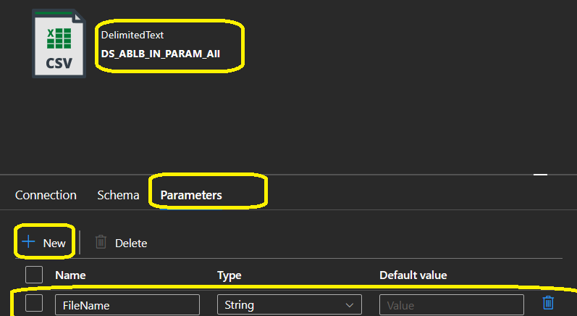

Create Parameter does not mean it will use it. You have use it somewhere. This is same logic in other programming or database languages. Create variable does not mean it will work, you have to use it some where and you need to set values also.

2**) Use it inside dataset connection area**



**3) Now you have Parameter at Dataset, hence you must need to pass value into parameter from pipeline or Activity.**

We have file at foreach loop so we do not need to create parameter at pipeline. foreach loop have filename as

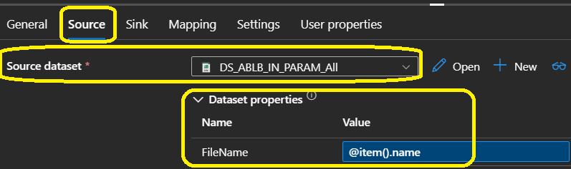

1. Here you have Metadata Activity which gives list of files to foreach loop.
2. Foreach loop run iteratively and pass each file name to copy activity as source.
3. Copy activity move current file to Azure Data Lake gen.
4. So, once you implement above solutions, now as per requirement your solution should work for more than one business outcomes so you need to pass external values. Hence you need to create parameter at pipeline level as well.
5. Create a Parameter “BO_NAME” at pipeline level.
6. Create new Parameter at dataset level as “BO_NAME”
7. Use that in Dataset level on “connection” as @dataset.BO_NAME
8. Now pass value to dataset “BO_NAME” parameter from pipeline parameter
9. @dataset.BO_NAME = @Pipeline.parameters.BO_NAME
10. NOTE, in enhance solution, we have used parameter at Pipeline level, So, now you have parameter at pipeline level and dataset level. Dataset level

**Final solutions:**

1. **Parameter at Pipeline**

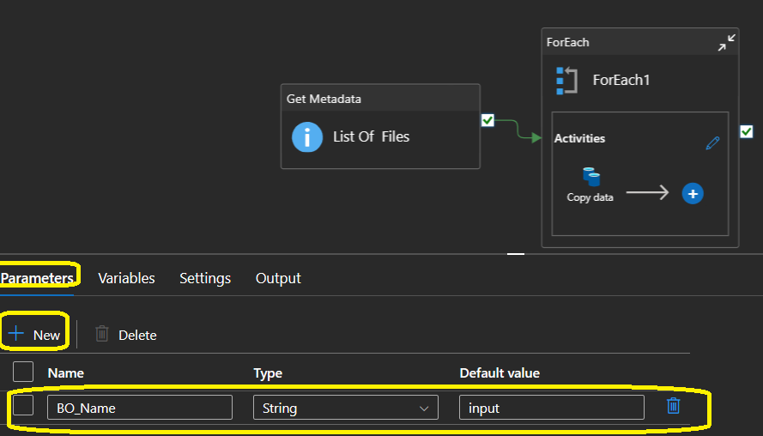

2) Meta data Activity, use above parameter to get list of files from that container or for that BO. Hence you also need to create same param in Dataset for Metadata Activity

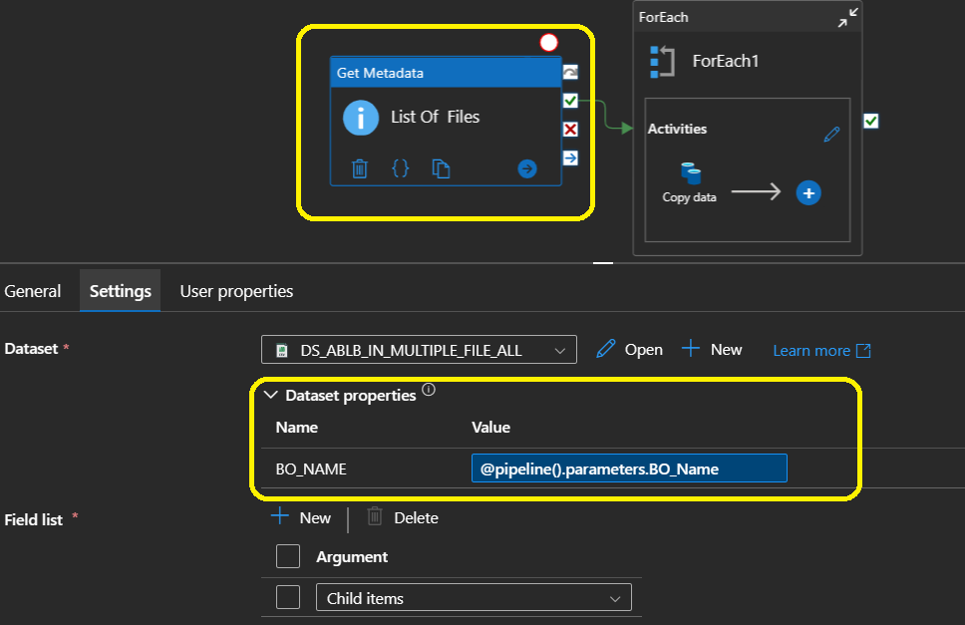

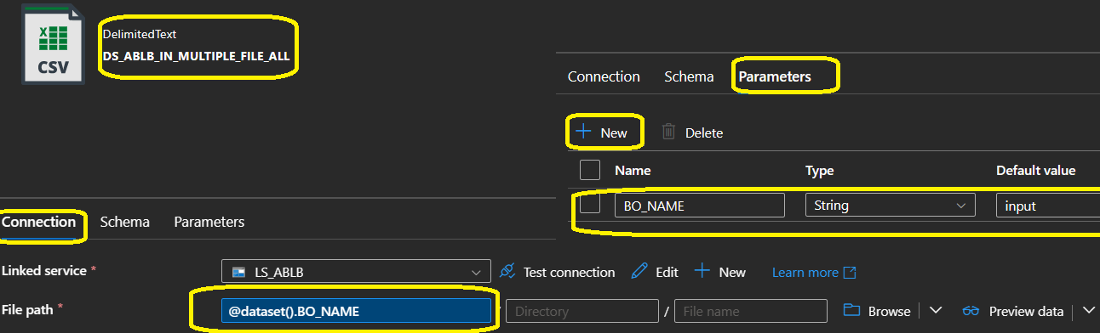

3) So now you have list of files based on BO. Now you need to copy file from Azure Blob Storage to Azure Data Lake Gen 2 . Here you have foreach loop pass current file to Dataset and Pipeline parameter “BO_NAME” will pass Business outcomes name so Copy activity get ideas where to place file and where to pick file. Result of previous activity “List Of Files”.

@activity(‘List Of Files’).output.childItem

